Tommy Walton

CS 500

Herron

4/17/2015

Project 3: Recursion, Transmission, and Antialiasing

### Project Description

This project makes two additions to project 2, a recursive algorithm for reflections and transmissions, and a process for antialiasing.

### Recursion

Reflective spheres with a roughness of 0.1, 0.4, and 0.7.

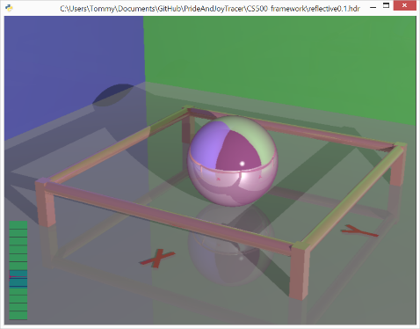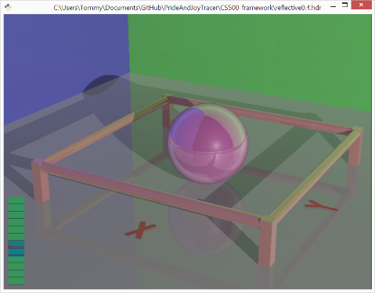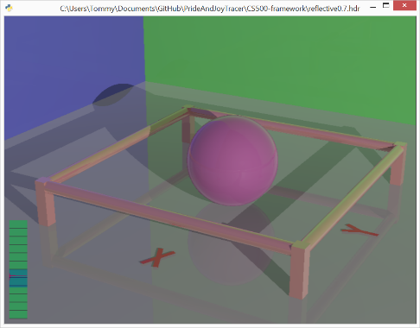

Transmissive spheres with an index of refraction of 1.3, 1.5, and 1.7.

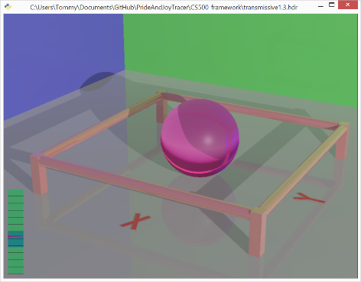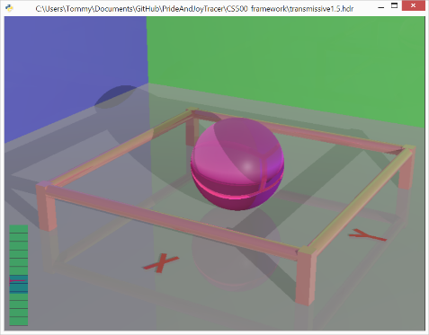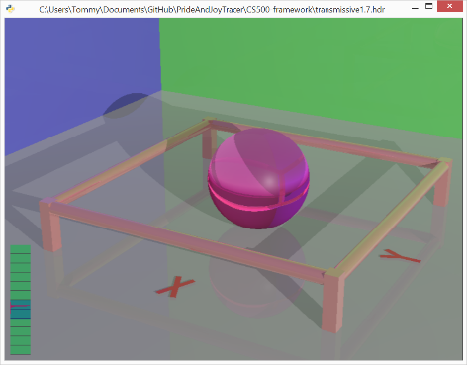

### Antialiasing

Antialiasing off (top) vs. Jittering 3x3 (bottom)

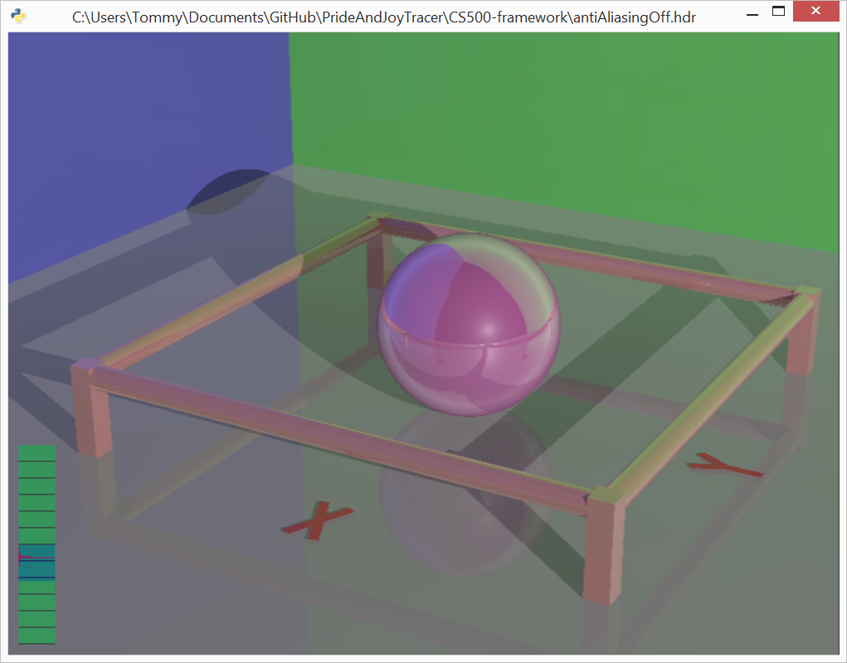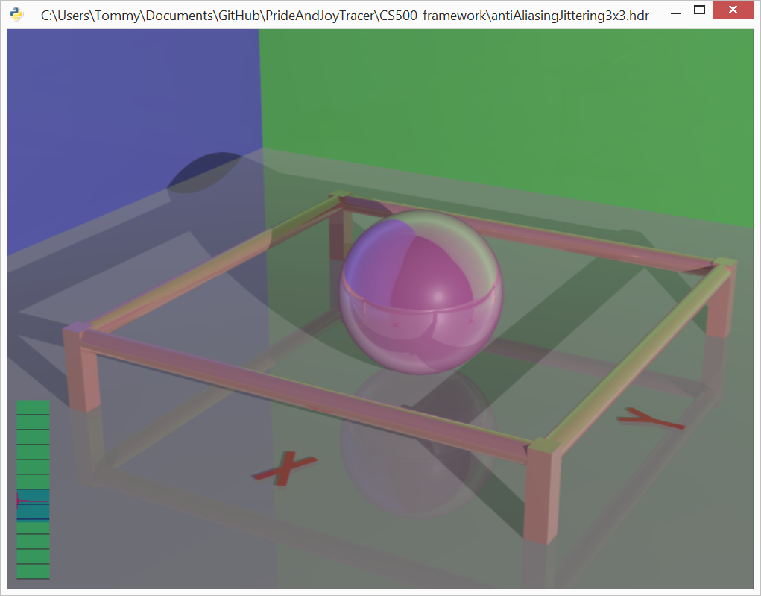

Antialiasing Off

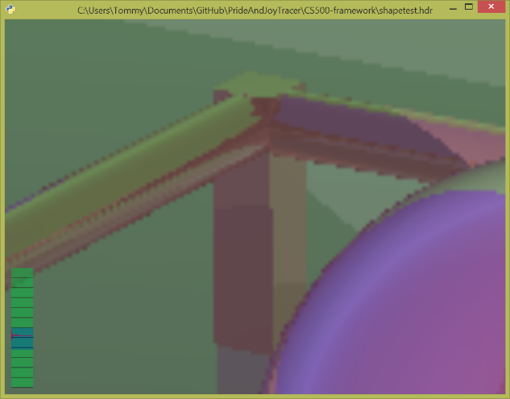

Antialiasing 2x2 (left) vs. 3x3 (right)

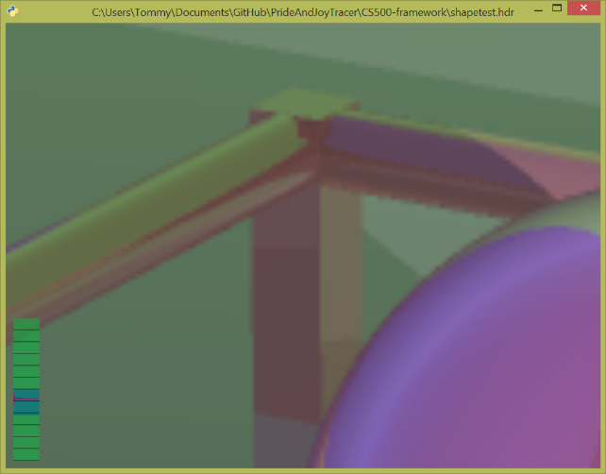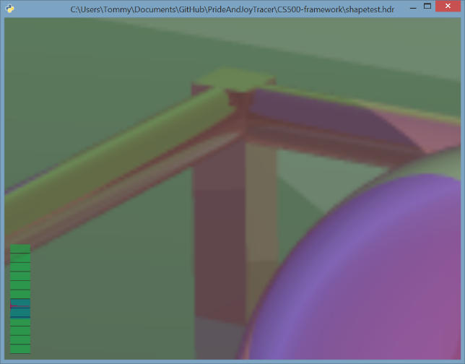

Antialiasing with Jittering 2x2 (left) vs 3x3 (right)

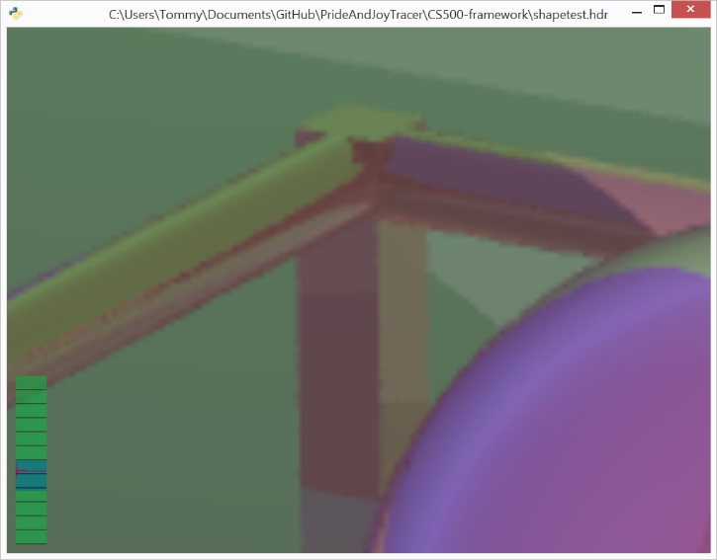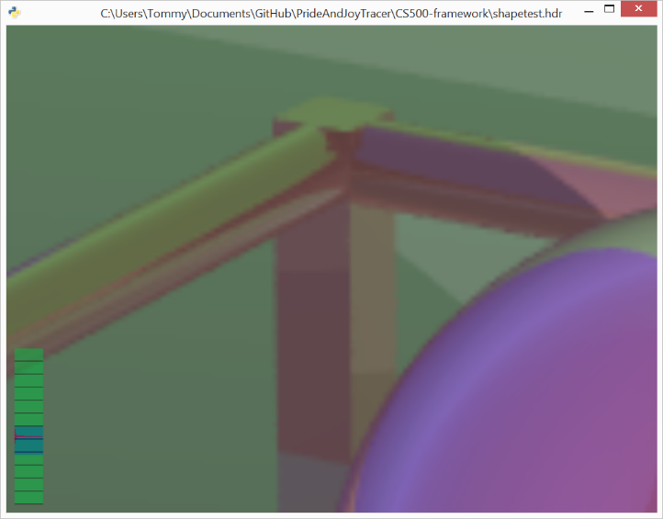

### Build and Run Instructions

The project was built using Visual Studio 2013. I modified the format of the scenetest.scn slightly. If a line in the .scn file starts with “antialaising”, the first number on that line controls the type of antialiasing. 0 is off, 1 is antialiasing with a uniform grid, and 2 is antialiasing with jittering. The second number on that line indicates the number of rowas and columns used in the NxN grid for the antialiasing. Otherwise, the project runs just like the project 2 and can be run with run.bat.